

**CIS 11042 – Practical for Essential of ICT and PC Applications**

**Information And Communication Technology**

**Faculty of Technology**

**South Eastern University Of Sri Lanka**

***Reg. Number:*** *SEU/IS/22/ICT/075*

***Academic Year:*** *22/23*

***Practical Number:*** *Lab Sheet 20*

***Title:*** *Utility programs, Utility packages and Driver installation*

**Aims:**

• Getting familiar with utility programs, packages

• Getting to know drivers and installation of drivers.

**Tasks:**

2. In the search bar search “control panel” 🡪 open “control panel” 🡪 then you   
    can see this.

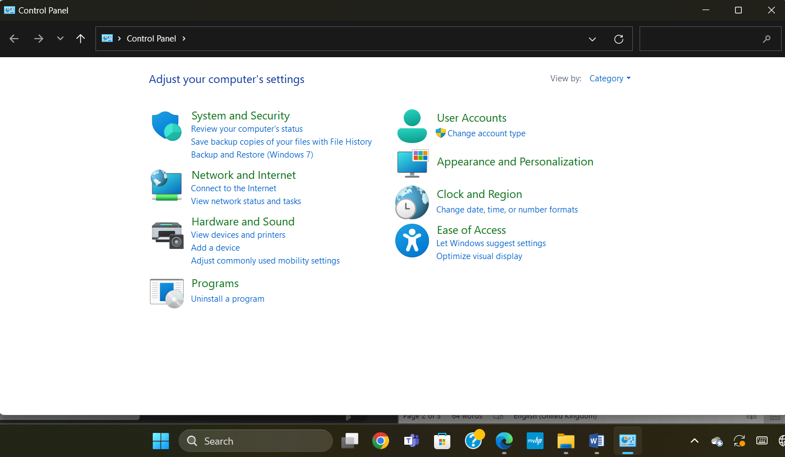



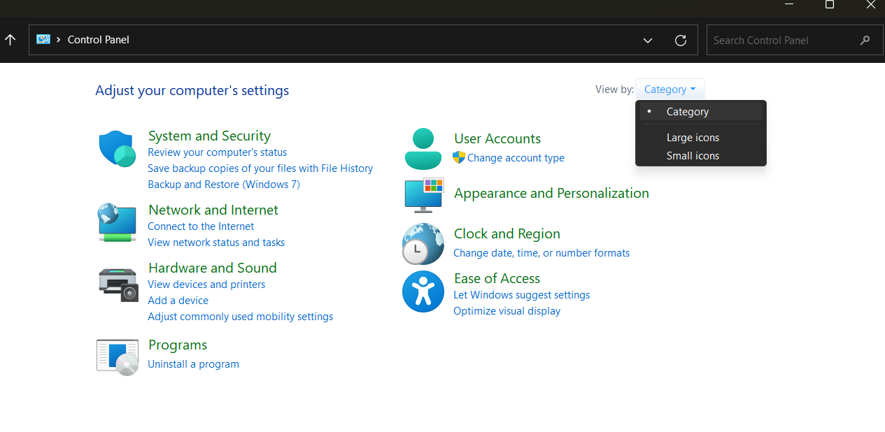



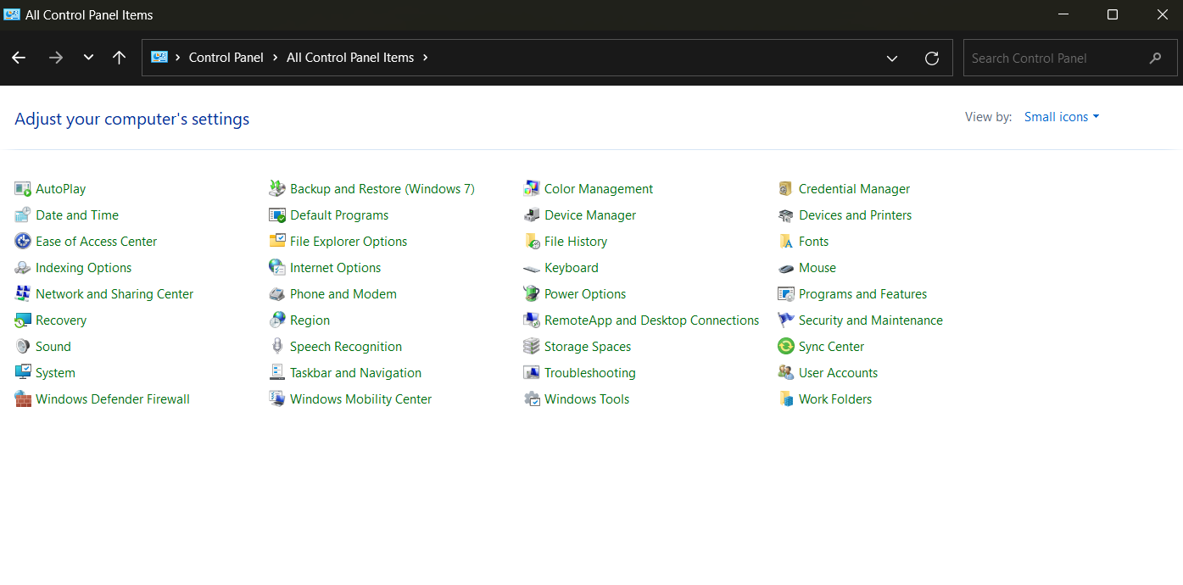

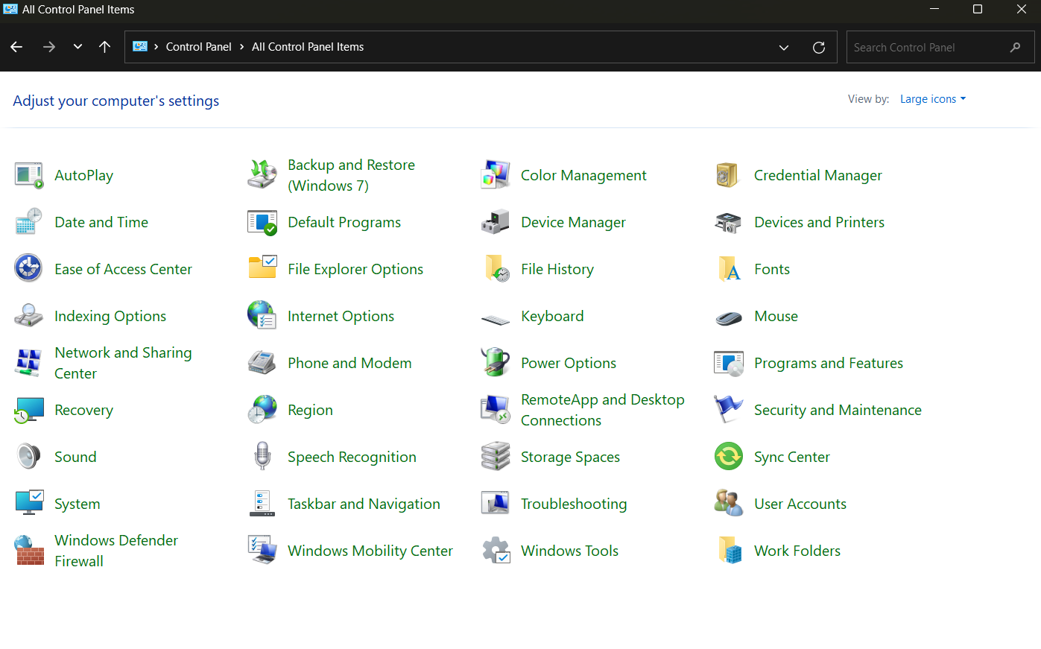

1. 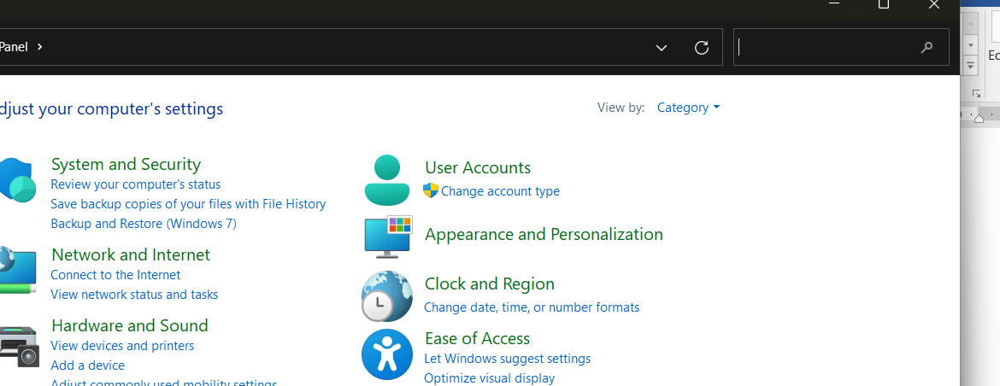

1. Open the Start menu 🡪 Search for “Control Panel” 🡪 Browse through the list  
    of utilities.
3. Open Control panel 🡪Then click User Accounts 🡪 Click manage another   
   Account 🡪 Click “add a new user in PC settings” 🡪 Open bellow Tab 🡪  
   click “add account”.

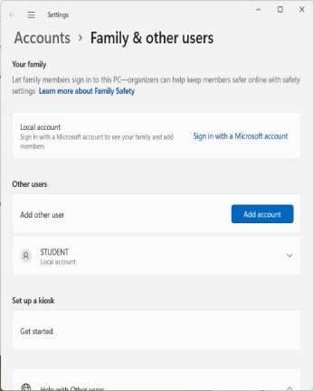

2. 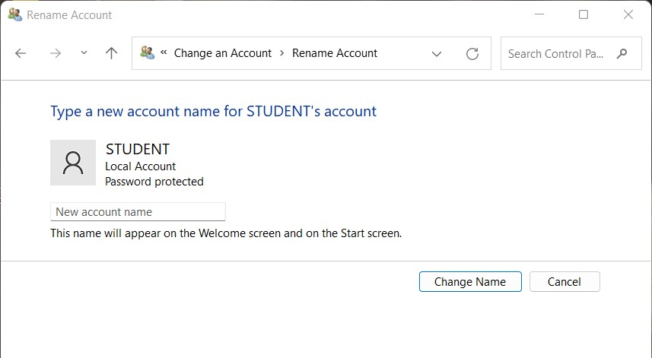Open Control panel 🡪 Then click User Accounts 🡪 Click “Manage other  
   account“ 🡪 Click Account in you want to change 🡪 Click “change account  
   name”.
3. 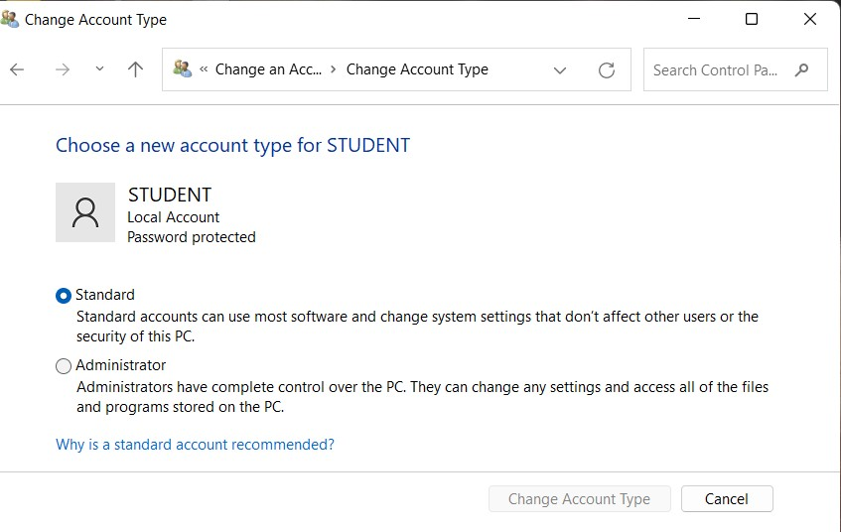Open Control panel 🡪 Then click User Accounts 🡪 Click “Manage other   
   account“ 🡪 Click Account in you want to change 🡪 Click “Change the  
   Account type”.

1. 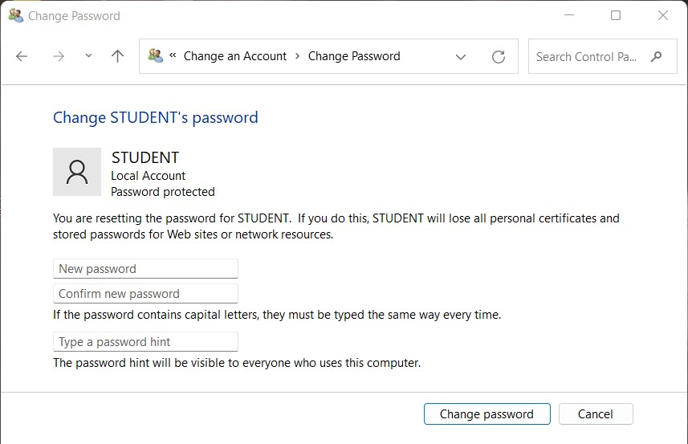Open Control panel 🡪 Then click User Accounts 🡪 Click “Manage other  
   account “ 🡪 Click Account in you want to change 🡪 Click “Change   
   Password”.
2. 1. Open control panel 🡪 Click Hardware and Sound 🡪 Click Device Manager.

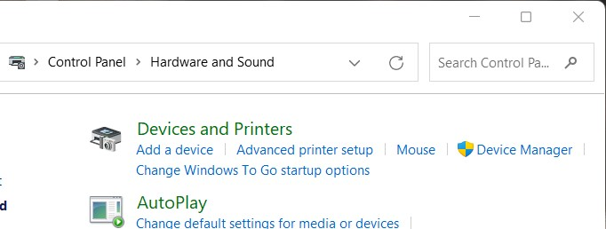



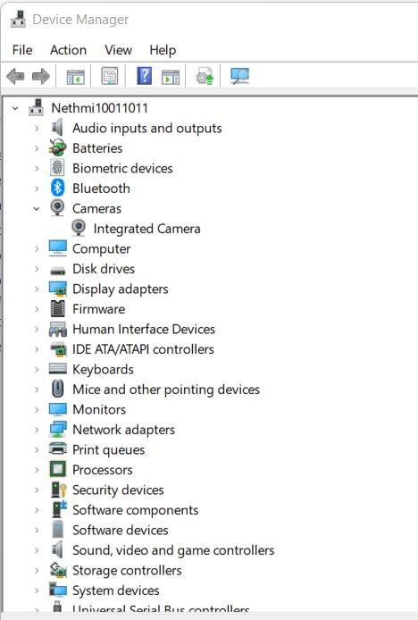

2. Select Settings 🡪 Update & Security 🡪 Windows Update after clicking Start 🡪  
   Alternatively, you can use the shortcut button below to get there: Update  
   Windows 🡪 To check for updates, click Check 🡪 Click See optional updates now   
   Choose the drivers you wish to update by clicking Driver updates 🡪 To install, click  
   Download.

1. Plug and Play drivers.
3. Open Disk clean up Tab 🡪 Select the drive 🡪 Choose files to delete 🡪 Clean up  
   system files 🡪 Confirm deletion.

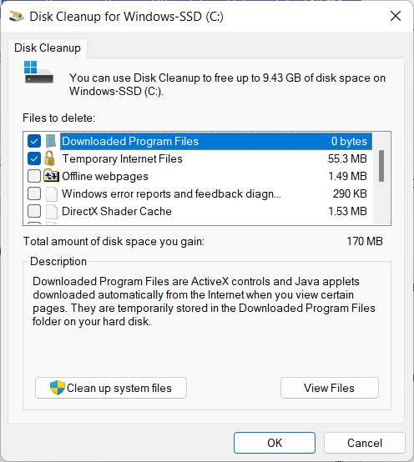

3. Look up "Disk Management" and launch the application 🡪 Choose   
   "Format..." when you right-click on the intended drive or partition 🡪  
   After setting up the parameters as previously mentioned 🡪 click "OK".

1. Open start menu 🡪 Click system 🡪 Click storage 🡪 Click “Advanced  
   storage settings” 🡪 Disks & volumes 🡪 Click properties 🡪 Select the new  
   drive letter.

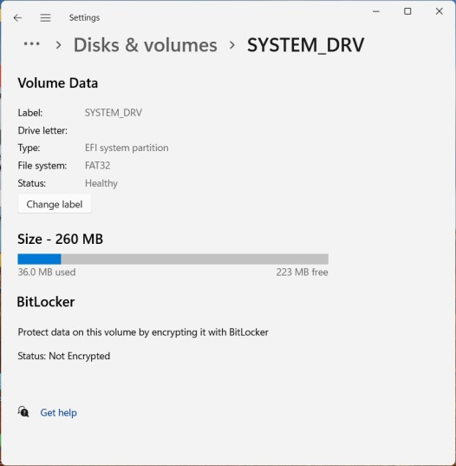

1. Use the “Windows key + R” to open Disk Management 🡪 then type "diskmgmt.msc " 🡪 hit “Enter” 🡪 Locate the partition that you wish to   
    enlarge 🡪 which is often "C:" for the system disk 🡪 Choose "Shrink  
    Volume..." with a right click on the partition.

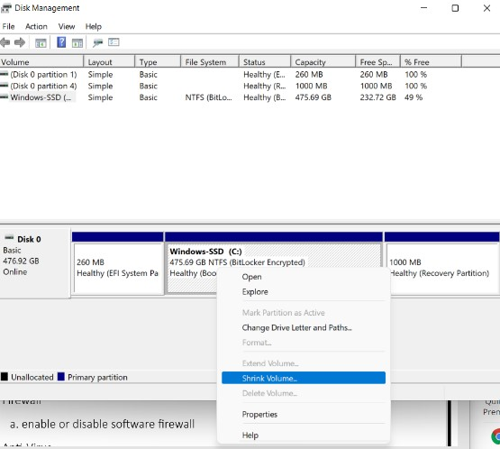

2. Search for “Defragment and Optimize Drives” 🡪 Select the disk you want to  
   defragment 🡪 Click “Optimize”.

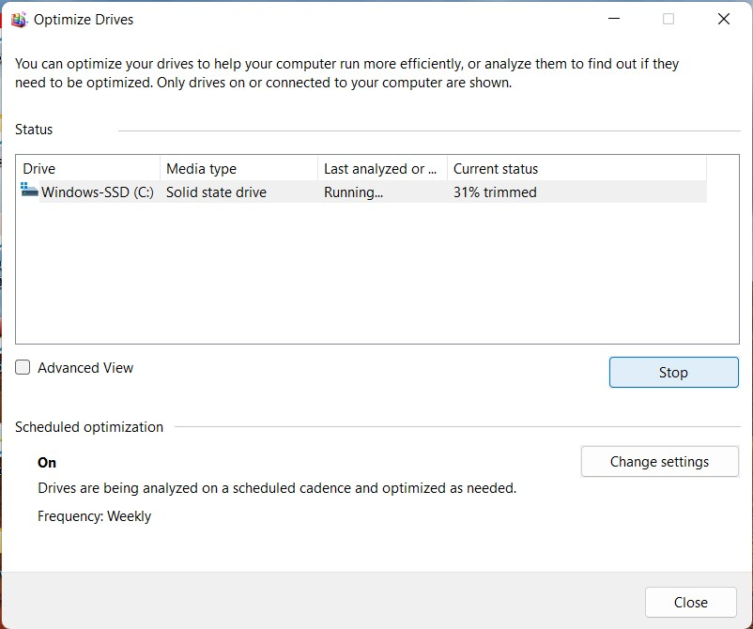

2. Click on the Start 🡪 Select settings 🡪 Go to “privacy & security” 🡪 Go to  
   windows security 🡪 Go to “Firewall & network Protection” 🡪 Select the network  
   profile you want to modify 🡪 Under Microsoft defender firewall, toggle the   
   switch to On to enable it or Off to disable it .

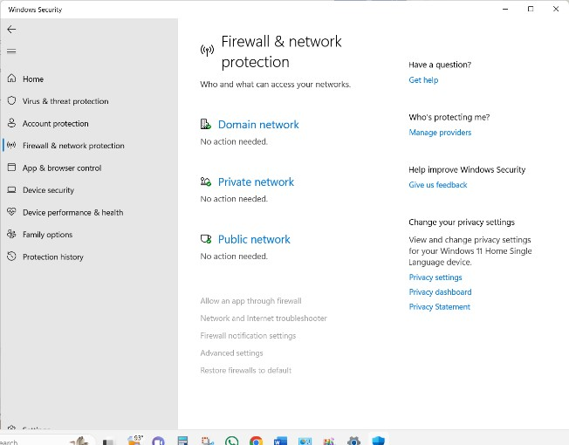

2. Search virus & threat protection 🡪 Click Microsoft Defender Antivirus Option.

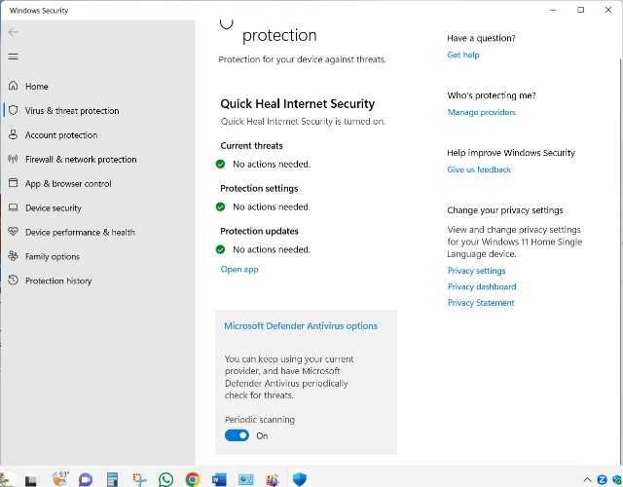

2. 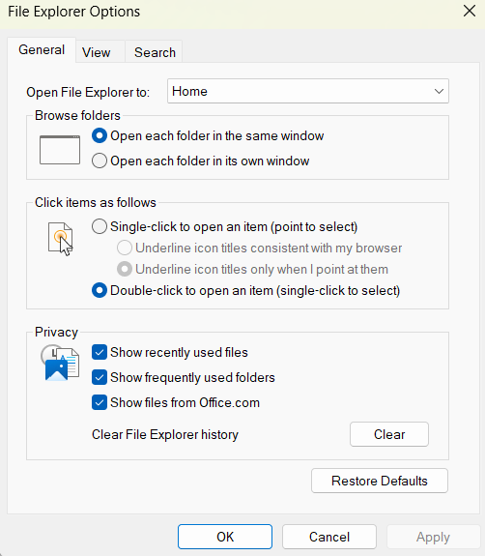
4. 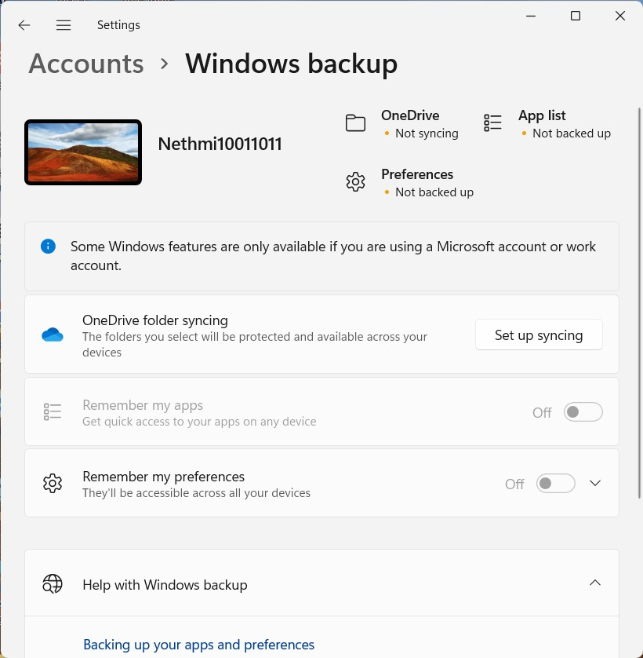Go to setting 🡪 Then select Account 🡪 Go to Windows Backup.

1. 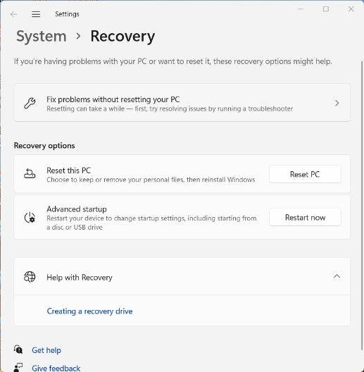Go to settings 🡪 Go to system 🡪 Go to Recovery 🡪 Click reset PC.

2. Search create restore point 🡪 Open system property tab 🡪 Click system  
   Protection 🡪 Then create button.

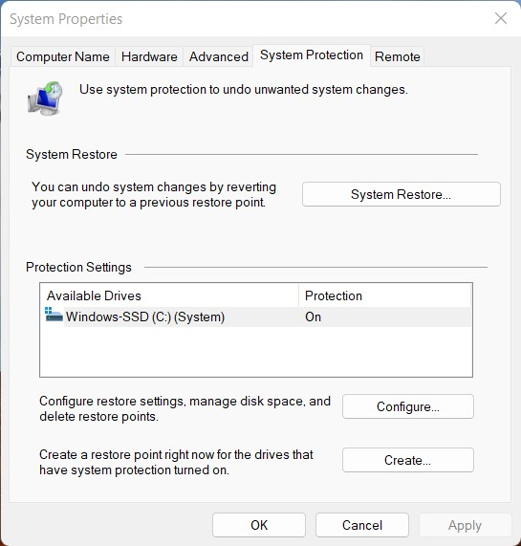

1. Search create restore point 🡪 Open system property tab 🡪 Click system   
   Protection 🡪 Then system restore button.



2. 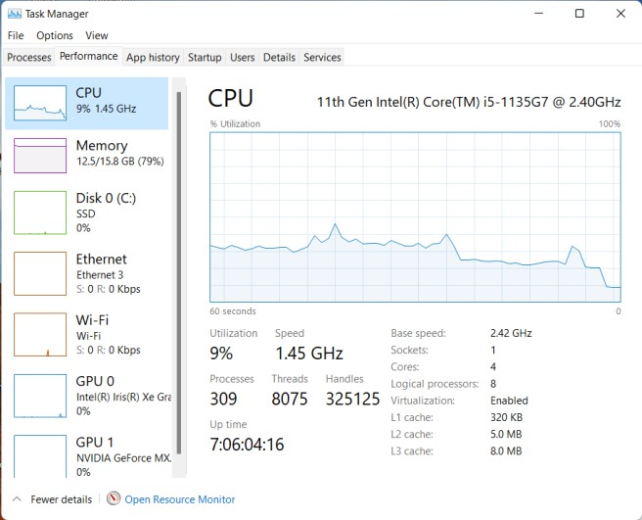Search Task Manager 🡪 Open task manager tab 🡪 click performance.
3. Open Task Manage 🡪 Click Processes 🡪 Click task you want to End 🡪 Then End  
   Task Button .

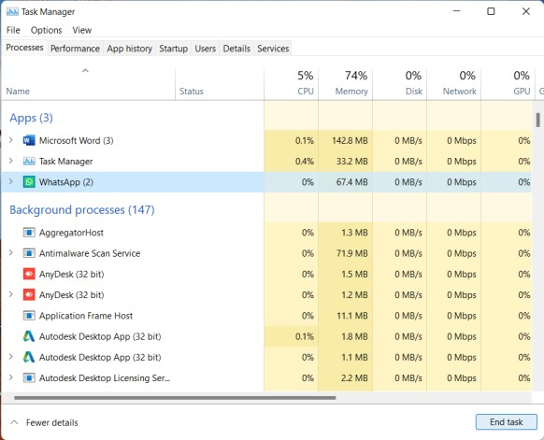

**Discussion :**

**1. Control Panel**

* The **Control Panel** is used to change Windows settings.
* You can view it in:
  + **Category**
  + **Small icons**
  + **Large icons**
* You can **search** for specific tools.
* Common tools: Programs, Internet Options, Hardware and Sound.

**2. User Account Creation**

* You can create new users on the computer.
* Set different **user privileges** (Admin or Standard).
* You can:
  + Change user name
  + Change user type
  + Change user password

**3. Device Management**

* Open **Device Manager** to see all connected hardware.
* Check if devices are working correctly.
* Identify hardware problems and fix them.

**4. Driver Installation**

* Drivers connect hardware to your computer system.
* **Plug and Play** drivers install automatically.
* Other drivers may need to be **installed manually**.

**5. Disk Cleanup**

* This tool helps delete:
  + Temporary files
  + Unused files
* It frees up space and makes your computer faster.

**6. Disk Management**

* Used to manage your hard drive:
  + **Partition** the disk (divide into parts)
  + **Format** partitions
  + **Change** drive letters
  + **Extend or shrink** a volume (resize)

**7. Disk Defragment**

* Reorganizes scattered files to make your computer faster.
* It is helpful for **hard disk drives (HDD)**.

**8. Firewall**

* A **firewall** protects your computer from online threats.
* You can **enable or disable** the Windows firewall.

**9. Antivirus**

* **Windows Defender** is the built-in antivirus in Windows.
* It protects your computer from viruses and malware.

**10. Windows Explorer and Features**

* **Windows Explorer** is used to browse files and folders.
* You can also enable or disable certain **Windows Features** (like .NET Framework, etc.).

**11. Backup and Restore**

* **Backup** is used to save a copy of your data.
* **Reset** helps return the system to factory settings.
* Useful if the system is slow or has problems.

**12. Restore Point**

* A **restore point** saves the system settings.
* You can **restore** your system to an earlier time if there is a problem.

**13. Task Manager**

* Helps you watch how your computer is working:
  + **CPU** usage
  + **Memory**
  + **Disk**
  + **Network**
  + **GPU**
* You can **end tasks** that are not responding.

**Reference :**

* Microsoft Support: <https://support.microsoft.com>
* Windows Control Panel: <https://www.howtogeek.com>
* Device Manager: https://www.lifewire.com/device-manager-2624477
* Disk Management: https://www.diskpart.com/articles/windows-disk-management.html
* Windows Defender: <https://www.microsoft.com/en-us/windows/comprehensive-security>
* System Restore: https://www.tenforums.com/tutorials/
* Task Manager Guide: https://www.windowscentral.com/how-use-task-manager